Fantasy game Heroes of Pymoli.

Data Analysis

Based on the data provided:

The company has a positive income of 2379.00, their customer data shows that Males represent 83 % of their total market and only 14 % of their customers are Females. Males are the ones who have a bigger contribution to Company’s revenue as it shown within the below tables.

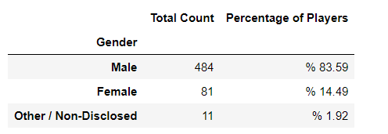

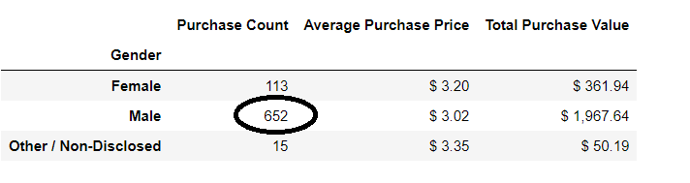

Base on player’s edge, I observe that gamers between 20 and 24-year-old are the one who actively buy more items than others. This segment makes more than 45 % of the total company revenue ($1114.00 out of $2379.00), which is something that we need to highlight

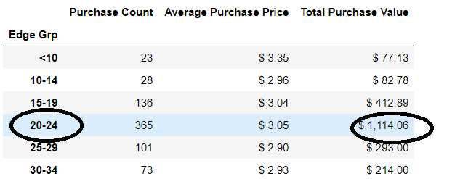

Talking about items popularity and profitability, I can see that item 178 called Oathbreaker is the most popular item between players, and there are some quite bit in the second place. But taking about revenue by item, 178 item is still at the first place followed by 82- Nirvana item. In despite of its popularity, nirvana item is at the second place base on revenue, because it’s price is a litter bit higher that others.

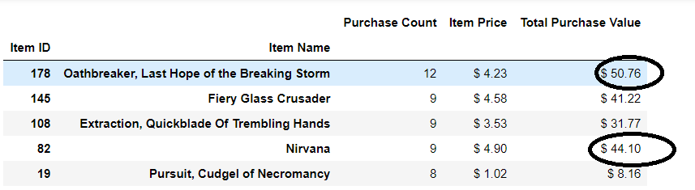

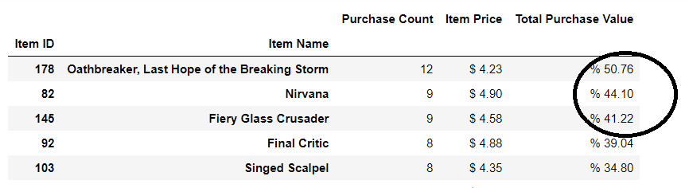

As a conclusion, males are still leading the game market based on this set of data. The gamer edge is so important for the business because we can observe that a player becomes more active at gaming when he or she is between 20 to 24 years old (where chances are they have their own income to but items). As any other business there are some items that are more popular than others but not necessarily made a significant contribution to the revenue the company must be aware of it.

Miguel Rojas